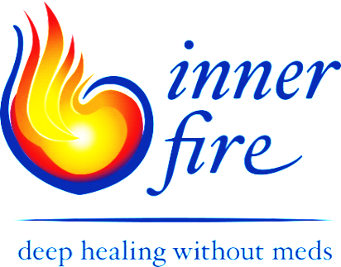

November 2019

Dear Friends,

Thanks to your generosity, we raised over a million dollars and completed Inner Fire’s East Wing—which has been home for Seekers since January. This is a heartening and tremendous accomplishment! Thank you! My heart also smiles to recall the number of hours envisioning the ‘home,’ aiming for it to be in itself a beautiful and healing space. And, it is! Remember: “Food feeds the Body, and Beauty feeds the Soul!”

Now in our 5th year, we remember the 27 courageous and striving individuals who, having been traumatized by forced medication and hospitalization, discovered Inner Fire. Inner Fire offers choice to those longing for the opportunity to reclaim their lives by working with and digesting traumatic life experiences in a safe community guided by Love and Wisdom.

The choice we offer appeals to those who seek to either avoid medications altogether, or who long to taper completely or to find a supportive dose they can live with and feel fulfilled, or who need support as they manage the awful withdrawal symptoms of benzodiazepines and other psychotropic medications from which they have previously tapered. As individuals engaged in a program which appeals to the whole human being, they discover and develop their own inner strengths which will serve them as their life unfolds.

I recently received another email from a distraught sibling sharing the tragic death of a family member who chose suicide over living disconnected from what essentially makes us human due to the side effects of the psychotropic medications….Will we wake-up? Medications do not work for everyone, and the choice to be proactive and digest, rather than avoid traumatic life experiences, is essential. How else do we grow and evolve as individual human beings?

We live in a society which tends to reduce the human being to parts. The rampant use of psychotropic medications can cause chaos within the soul leaving one disconnected from much of what makes us human such as clarity of thinking, heartfelt feelings, and the will to act with intention. How will our children, our future leaders, manage to deal with challenges which simply belong to life if they are disempowered by such medications? What will life look like in the future?

The completion of the East Wing is significant, but we must not rest. As our numbers grow, we need more space to be able to come together as a community. In addition, appreciating the desperation and exhaustion of parents who declare, “I need Inner Fire!” the Barn could also serve as a gathering place for parents and practitioners, who also long for a broader perspective to support deeper healing. Many practitioners know the meds may work for some, but are disastrous for others.
Would you help us? Please consider two ways you can help the choice Inner Fire offers to become visible and thereby save lives:

Donate to the Building Fund: To complete the Arts and Drama Barn we need only $300,000. We would like to start building immediately! (see enclosed sketch of Barn)

At this time, building the Barn is a priority, as it will serve the immediate Inner Fire community, the neighboring community (through the theatrical productions we aim to offer) as well as family members and practitioners.

Donate to the Support a Seeker Fund: Help a striving individual have the opportunity to be proactive in their healing process who, without the funding, would not have the opportunity.

It is essential that Inner Fire be available for individuals from all religions, races and financial backgrounds, so that we can simply meet in our humanity. Thus far, we have managed to support three Seekers for over 2 years but the ‘Support a Seeker Fund’ is empty.

Thank you for your thoughtful consideration and for your support. We, and so many others, depend on your generosity.

On behalf of the Board, Guides, Seekers and future Seekers at Inner Fire,

Beatrice Birch
Founder/Executive Director/Hauschka Artistic Therapist

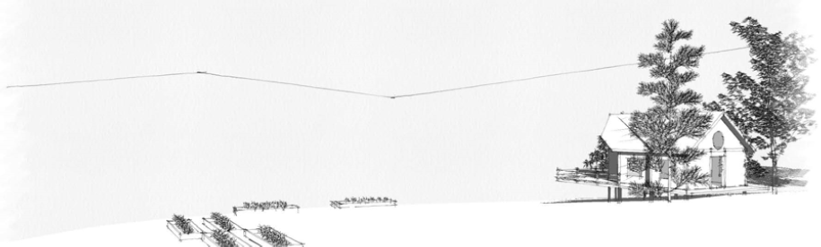

The Arts and Drama Barn - thank you for helping it become a reality!

