December 2018

Dear Friends!

As we look back on Inner Fire’s three years of operations – I am amazed. Amazed at the healing that has transpired, the lives that have been changed, the skills of the extraordinary staff at Inner Fire and the incredible generosity of those of you who have made all this possible.

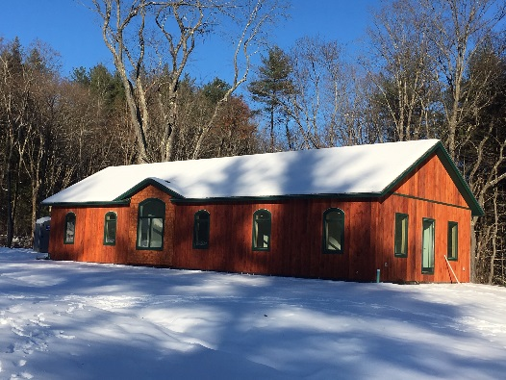
We are now building the capacity for greater service in the form of a campus that can house 12 seekers, therapy spaces and related out-buildings. We are about to finish the first of these buildings, the East Wing, that will house 8 seekers and provide limited therapy spaces, along with the house at Grace Brook Farm. Getting this first facility built has also been amazing! It included permitting, design, sitework, installation of utilities, and the construction of the first of four main buildings. We have raised more than $800,000 for the work done to date and need another $1.9M to finish the campus. This will be an ongoing effort via our Capital Campaign over the next year in which we hope you can help.

We are also hoping to install solar panels on the East Wing, to power virtually all systems in the new building, including heat. To this end, we are launching a GoFundMe effort to raise $26,000 in the next two months. To those of you who have already sent donations for this, we thank you! For those able to help us at this time, please visit the GoFundMe link at https://www.gofundme.com/Solar-Power-for-Inner-Fire-Healing-Without-Meds and then let your friends on social media know about this! This year, we moved our Facebook page and invite you to “like” us on our new Facebook page at https://www.facebook.com/innerfire.us/. Also, an Instagram posting or a Twitter tweet can let others who may never have heard of Inner Fire, share in its mission.

We are so grateful for the generosity you have shown to Inner Fire in the past and hope you will continue to make this work possible through your continued support.

With Appreciation,

Beatrice

